HOMESTEADING IN WYOMING
(1910 – 1912)

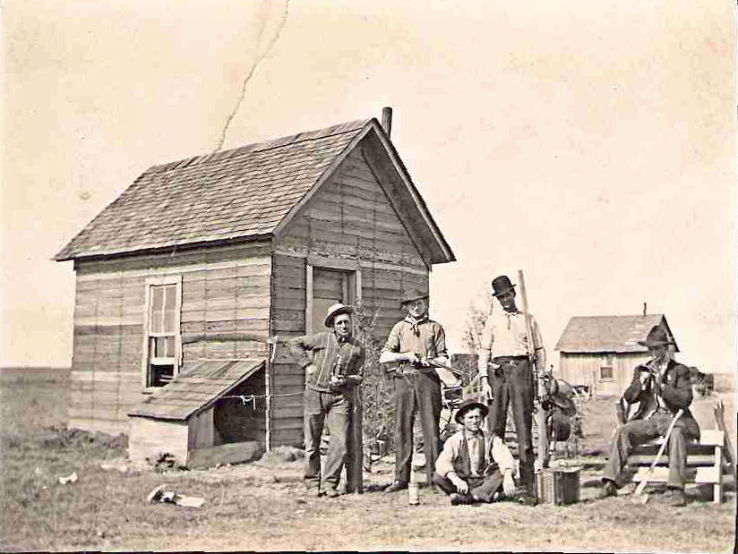
Ed & Joe Janousek, Joe Kasper, Jim Krisl (assumed) and Rudy Krisl (Undated)
~~~~~

For Additional Information, Contact –

Sharon Lawrence
P.O. Box 13541
Austin, TX 78711
(512) 837-5670

The lighter side of homesteading in Wyoming
Ed or Joe Janousek, Jim Krisl, Ed or Joe Janousek & Rudy Krisl
~~~~~

Milligan, Nebraska Residents
Homestead in Wyoming

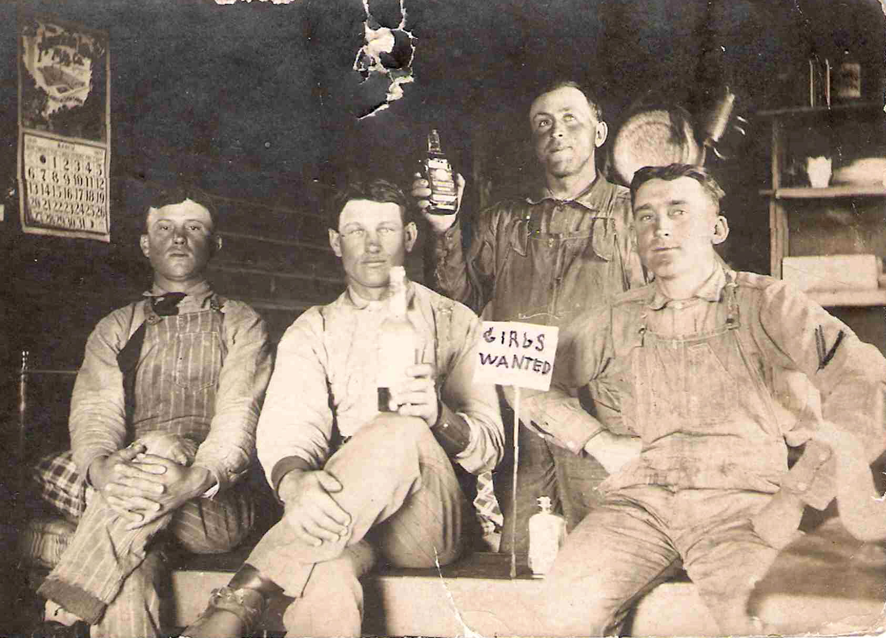
Joseph Janousek, John Eret, Frank Franek, and Albert Fricek left for Cheyenne, Wyoming Wednesday. (Milligan Times, August 20, 1909)
~~~~~
Joe Janousek and Frank Franek returned last Saturday from Wyoming where they are homesteading. The boys like the wild west country better than the life out here and will return in the spring. Joe is going into the cattle business having purchased 72 young head already. (Milligan Times, October 22, 1909)
~~~~~
Joe Janousek, Frank Franek, E.A. Kotas and Emil Korbelik drove to Exeter this morning. From there they will take a train for Wyoming. (Milligan Times, February 25, 1910)
~~~~~
Ed Stastny informs us that he will move to Wyoming in the spring, where he, with a number of others from his town, have taken homesteads. (Swanton News, as reported in the February 25, 1910 Wilber Republican)
~~~~~
Joe Janousek of Chugwater, Wyoming came here the latter part of last week and is making ready to ship his cattle and horses to Wyoming. (Milligan Times, May 6, 1910)
~~~~~
Janousek brothers and Ed Stastny shipped their car of household goods and stock to Chugwater, Wyoming Tuesday, near which place they will all make their future home. Joe Janousek accompanied the car and Mr. and Mrs. Ed Stastny and Ed Janousek followed Wednesday. (Milligan Times, May 13, 1910)
~~~~~
Frank Franek of near Chugwater, Wyoming, came to Milligan Tuesday morning. Mr. Franek will remain here for some time, after which he will return to Wyoming where he will again join his pal Joe Janousek. (Milligan Times, August 19, 1910)
~~~~~
Mr. Emil Korbelik shipped his livestock and farm machinery and feed to Chugwater, Wyoming the latter part of this week. Mr. Korbelik will put up a house on his farm near Chugwater and will come back after his family and household goods. (Milligan Times, September 2, 1910)
~~~~~
Albert Fricek left for Chugwater, Wyoming the latter part of last week. Mr. Fricek has taken up a 160 acre tract of land near that place and will prove up on the same. (Milligan Times, September 23, 1910)
~~~~~
Joe Janousek, Jr. of near Chugwater, Wyoming came here Thursday evening to visit with his home folks and other relatives for a few days. (Milligan Times, January 20, 1911)
~~~~~
Herman Stastny, Jim Motis, and Fred Placek went to Wyoming the fore part of the week to look over the country and visit friends. (Milligan Times, February 10, 1911)
~~~~~
Joe Janousek and John Chmelka left for Chugwater, Wyoming today. (Milligan Times, March 10, 1911)
~~~~~
Mr. and Mrs. Ed Stastny and Ed Janousek moved back to Milligan, arriving Thursday morning after spending a little over a year in Wyoming. (Milligan Times, August 18, 1911)
Notice for Publication –
Department of the Interior
US Land Office at Cheyenne, Wyo
June 14, 1911

Not Coal Land

Notice is hereby given that Edward Stastny of Chugwater, Wyoming, who on November 4, 1909, made Homestead Application Serial No. 95249 for northeast ¼, Section 34, Township 21 North, Range 65 West, 6th P.M., has filed notice of intention to make final commutation Proof to establish claim to the land above described before David W. Brice, U.S. Commissioner at Wheatland, Wyoming, on the 18th day of July 1911.

Claimant names as witnesses Herman Lutske, of Chugwater, Wyo., William McGraw of Chugwater, Wyo., Ed Janousek of Chugwater, Wyo., John Eret of Chugwater, Wyo.

W.E. Chaplin, Register
~~~~~
John Eret came from Chugwater, Wyoming the latter part of last week to visit relatives and friends here, and will probably settle here again. (Milligan Times, September 8, 1911)
~~~~~
Mr. and Mrs. Will McGraw and son of near Chugwater, Wyoming, who are visiting relatives in Geneva, were in town Wednesday and Thursday and were the guests of Mr. and Mrs. Ed Stastny. (Milligan Times, September 29, 1911)
~~~~~
Fred Hrdlicka and James Korbelik returned from Chugwater, Wyoming Tuesday evening. Mr. Hrdlicka was so well pleased with the country and the crops that he decided to invest some money there, and has bought a half section of land with improvements. (Milligan Times, September 29, 1911)
~~~~~
Will McGraw and family of near Chugwater, Wyoming, came last week to visit with relatives and friends in and around Geneva. Mr. McGraw was in town Wednesday and informed us that he is well satisfied with the country where he and his family now live. Mr. McGraw reports having harvested a fair crop of oats and alfalfa and expects to do much better another year. (Milligan Times, September 29, 1911)
~~~~~
Mrs. Joseph Janousek and Mrs. Joseph Korbelik, accompanied by the little daughter of Mr. and Mrs. Emil Korbelik, returned from Wyoming this morning after spending a few weeks with relatives there. (Milligan Times, October 6, 1911)
~~~~~
Joe Janousek Jr. of near Chugwater, Wyoming came last Saturday to spend the winter here. (Milligan Times, November 10, 1911)
~~~~~
Emil Korbelik of near Chugwater, Wyoming is here visiting relatives and friends. (Milligan Times, December 29, 1911)
~~~~~
Joseph Janousek, Jr. left Wednesday afternoon for Chugwater, Wyoming near which place he owns several hundred acres of land and went there to look after his interests. James Rut and Frank Krisl Jr. accompanied Mr. Janousek as far as Exeter from where the latter took the train for the West. (Milligan Times, April 19, 1912)
~~~~~
Mr. John Chmelka returned from Chugwater, Wyoming last Friday after spending a little over a year in the state. (Milligan Times, July 5, 1912)
~~~~~
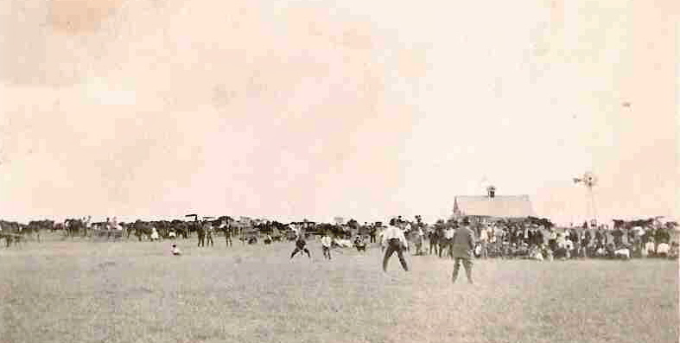
Over two hundred farmers east of Chugwater gathered at Joe Janousek’s to commemorate the day of the Declaration of Independence (see photograph above). Various amusements marked the features of the day. A ball game was played in the morning between Chugwater and Iowa Center. In the afternoon, the Ladies Aid of the M.E. Church rendered a short program. Rev. A. Evans, pastor of the M.E. Church, and C.A. Paige, of Wheatland addressed the gathering in a place that had been nicely decorated for the occasion by Mrs. Janousek.

The feature of the day was the wrestling match between the two Nickerson boys (see photograph below). The boys are only 12 and 14 but showed marked ability in the science of wrestling. All scientific holds used by scientific wrestlers were displayed by them and for more than thirty minutes they kept the audience cheering. Boxing, climbing a greased pole, steer riding, running and many other amusements added much to the enjoyment of those gathered there. The day as well as Joe will be remembered by those present, all of whom expressed their gratitude for the good time they had, and Joe is to be congratulated for the success of his efforts in making the gathering a success. (Wheatland World, July 12, 1912)
~~~~~

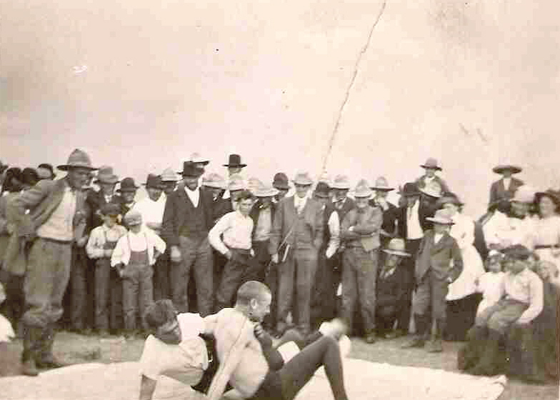
Emil Korbelik left for his home near Chugwater, Wyoming Tuesday morning after spending a few weeks here harvesting his wheat. Mr. Joseph Janousek Sr. went with Mr. Korbelik and will spend some time in Wyoming over the country; and also visiting with his sons, Joseph and Ed Janousek. (Milligan Times, August 9, 1912)
~~~~~
Joseph Kaspar and Emil and Rudolph Krisl went to Chugwater, Wyoming, Wednesday morning. The former two went there with the intention of filing on some land if they find anything suitable, and Rudolph Krisl were there to live with his brother James, who is holding down a 320 acre homestead. (Milligan Times, October 4, 1912)
~~~~~
Mr. Joseph Janousek Sr. returned from Chugwater, Wyoming last Friday after spending about two months with his sons Joseph and Ed. Mr. Janousek enjoyed his visit very much and was well pleased with the country. He ways the crops are good in that part of the country, especially the vegetables. Mr. Janousek says he saw larger squash and melons raised there than he has seen raised in Nebraska for many years. (Milligan Times, October 4, 1912)
~~~~~
Ed Janousek, Frank Franek, and James Krisl of near Chugwater, Wyoming arrived in Milligan last evening for a few weeks visit with home folks and friends. Mr. Franek will go on to Chicago in a few days to visit his mother, who resides in that city. (Milligan Times, November 8, 1912)
~~~~~
Messrs. James Rut and Henry Reschling returned Tuesday night from their trip to Wyoming. They spent about a week visiting friends near Chugwater and looking over the country. Both were well pleased with the country and Mr. Rut is thinking about moving to Wyoming in the spring and going into business there. (Milligan Times, January 31, 1913)
~~~~~
Fred Hrdlicka left for Wyoming the fore part of the week, after spending the winter here with relatives and friends. Jim Rut accompanied Mr. Hrdlicka to Wyoming and we understand that Mr. Rut intends to file on a piece of land. (Milligan Times, March 7, 1913)
~~~~~
Ed Janousek, Joseph Kaspar, and Emil Krisl loaded two cars of machinery and horses and all left for Chugwater, Wyoming, near which place they all have farms. (Milligan Times, April 11, 1913)
~~~~~
The “Chugwater Homestead Number 4170, Brotherhood of American Yeoman, will hold a special meeting June 13th in Joe Janousek’s barn. (Wheatland World, June 13, 1913)
~~~~~
Joe Janousek, formerly a resident of the Chugwater flats, but for the past two years residing at his old home in easter Nebraska, was a visitor in Wheatland last week. (Wheatland World, October 17, 1917)

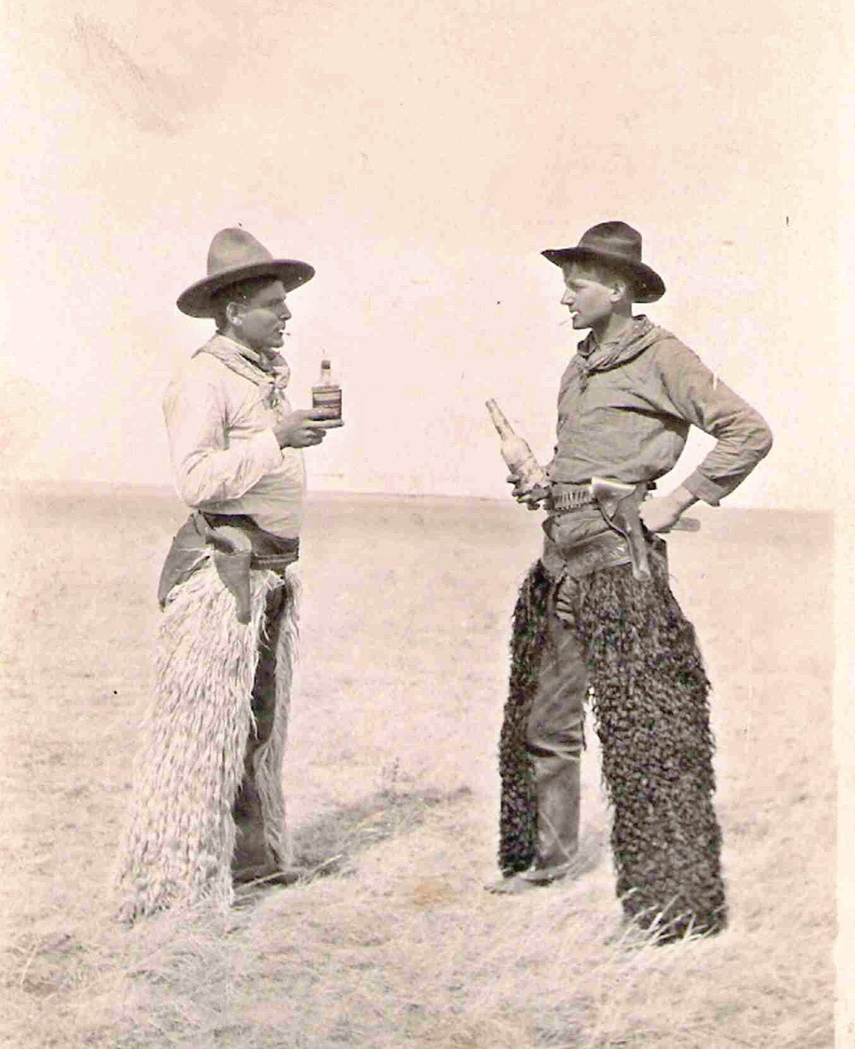

Frank Kriz & Rudy Krisl “having a hell of a time”

3/20/2009

Photograph from a set belonging to Emma Jamousek Slepicka and her sister, Agnes Janousek (Mrs. Ed) Stastny, of Milligan, Nebraska. The women were sisters of Ed and Joe Janousek and relatives of John Eret. Identifications for the photographs was completed with the assistance of the Chugwater Historical Unity Group.
The Wyoming Newspaper Project has scanned all of the pages of newspapers published in the state from 1849 – 1922. More than 900,000 pages are now available online at http://www.wyonewspapers.org.

